**Project Design Phase-I**

**Solution Architecture**

|  |  |
| --- | --- |
| Date | 13 May 2023 |
| Team ID | NM2023TMID14698 |
| Project Name | Deep learning Model for detecting diseases in tea leaves |

**Solution Architecture:**

Solution architecture is a complex process – with many sub-processes – that bridges the gap between business problems and technology solutions. Its goals are to:

* Find the best tech solution to solve existing business problems.
* Describe the structure, characteristics, behavior, and other aspects of the software to project stakeholders.
* Define features, development phases, and solution requirements.
* Provide specifications according to which the solution is defined, managed, and delivered.

**Example - Solution Architecture Diagram:**

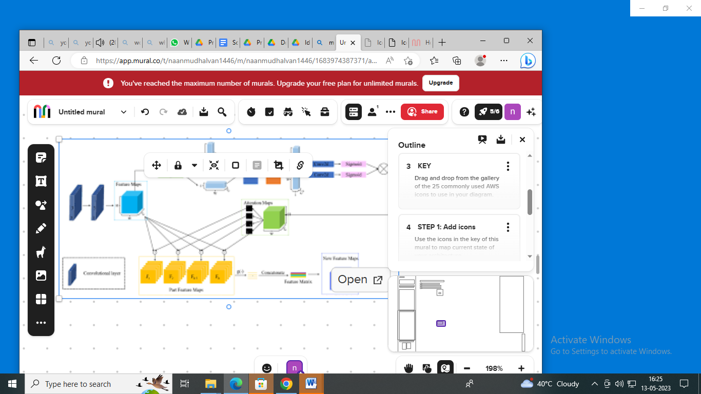

*Figure 1: Architecture and data flow of the voice patient diary sample application*

**Reference:** [Untitled mural • naan mudhalvan](https://app.mural.co/t/naanmudhalvan1446/m/naanmudhalvan1446/1683974387371/ae11afaa79a3e8756fd6d07b80ccad7386ae9329?sender=u4f5b5f6940a1e2ff5bd59062)